**AIM: -** Design a LED CHASER

**APPARATUS: -** Arduino Board, LED, Resistance- 220ohm, connecting wires.

**CIRCUIT DIAGRAM: -**

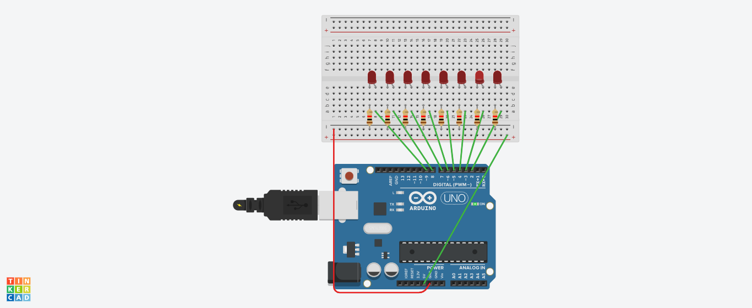

**THEORY: -**

An **LED** is a p-n junction with a heavily doped **n**-type semiconductor (**n**) and a lightly doped **p**-type. n-type side has more area than p-type side.

**Arduino** is an open-source electronics platform based on easy-to-use hardware and software.

**OBSERVATION: -**

Blinking of light

**PRECAUTIONS: -**

1. Insert connecting wires properly/ tightly .
2. Ground the n- type of LED .
3. Insert resistance at p- type
4. Write the arduino code properly.